Assignment #2

Question #1

#include<iostream>

#include<iomanip>

#include<time.h>

using namespace std;

int main()

{

int a, b = 0, count = 0;

srand(time(NULL)); /*Here we are Generating a random number by the system*/

a = rand() %100+ 1;

cout << "Enter a number :";

while (a!=b) /*Here we will taking the input by the user untill both the number will not same*/

{

cin >> b;

count++;

if (a>b) /*These following conditions are for the user Number actually where the Number is lying*/

cout << " Number is Greater than Target" << endl;

else if (b>a)

cout << " your Number is Lesser than Target " << endl;

else if (a == b)

cout << "You guessed the correct Number " << endl;

}

cout << "The toatl NUmber of Turns :" << count << endl; /*here this will about total counts */

system("pause");

return 0;

}

Output

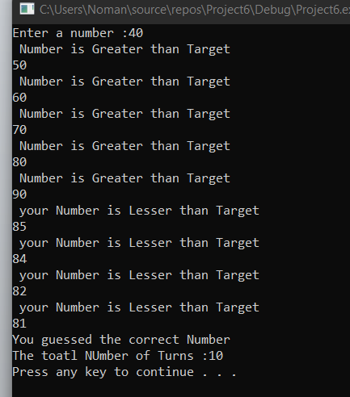

Question #2

Code:

#include<iostream>

using namespace std;

int main()

{

int fib1, fib2, position, fib3 = 0; /* Declaring & intializing the variables*/

cout << "Enter 1st Fibonachi Number = " << endl; /*Taking Input*/

cin >> fib1;

cout << "Enter 2nd Fibonachi Number = " << endl;

cin >> fib2;

cout << "Enter the position of Desired Fibo Number: ";

cin >> position; /*Taking input for the position*/

if (position == 1 /*These are conditions for following series*/

{

cout << "Fibonacci series = " << fib1 << endl;

}

if (position == 2)

{

cout << "Fibonacci series = " << fib2 << endl;

}

for (int i = 3; i <= position; i++) /*This is the condition for position of series */

{

fib3 = fib1 + fib2;

fib1 = fib2;

fib2 = fib3;

}

cout << fib3<< endl; /*Displaying the Series position */

system("pause");

return 0;

}

Output

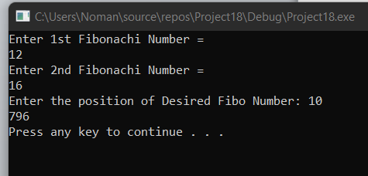

Question #3

Code:

#include<iostream>

using namespace std;

int main()

{

int popA,PopB, Year = 0;

float growA, growB; /*We will take these values in float because during in the formula its values in points*/

cout << "Enter the population of Town A :"; /*Here we are Taking input of following poluation and taking growth rate as input*/

cin >> popA;

cout << "Enter the Population of Town B :";

cin >> PopB;

cout << "Enter the Growth Rate of Town A :";

cin >> growA;

cout << "Enter the Growth Rate of town B:";

cin >> growB;

while (popA < PopB) /*when the values of population of A less Than B then it will true */

{

popA = (popA + ((growA / 100)*popA));/* These formulas will culculate the population of TownA &TownB*/

PopB = (PopB + ((growB / 100)*PopB));

Year++;

}

cout << Year << endl; /*Here we are displaying years of Growth*/

system("pause");

return 0;

}

**Output**

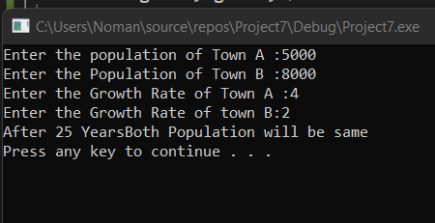

Question #5:

1. we need to update the logical expression because we have to follow the condition according to our task situation and also in the Loop counter(count++) must be updated
2. while loop has one control condition and execute as Long the condition is true when we have to count any number we will have to use **counter**

and when we don’t know how many times loop will execute we use **sentinel** and when we have to use true or false value or what’sever we will use **Flag**

1. we need to initialize a variable for while loop because this is the basic requirement of while loop
2. There should be statements inside the body of Loop or it may logical expressions
3. When the condition is falsed the Loop Terminates and it comes out side the loop or may execute other statements if any.

Question #6

Code:

#include<iostream>

using namespace std;

int main()

{

int size;

cout << "Enter the size of rows :";

cin >> size;

for (int i = 1; i <= size; i++) /*this for loop will covers the number of rows */

{

for (int j = 1; j <= size; j++) /*This for loop will cover the Number of columns */

{

if (i == 1) /*We are making following conditions according to our requirement*/

{

cout << "1 ";

}

else if (i == size) /*this condition is for the row number ,if the number comes equal to five .*/

{

cout << "1 ";

}

else if (j == 1)

{

cout << "1 ";

}

else if (j ==size)

{

cout << "1 ";

}

else /* for others numbers it will replace zero*/

{

cout << "0 ";

}

}

cout << endl;

}

system("pause");

return 0;

}

**Output**

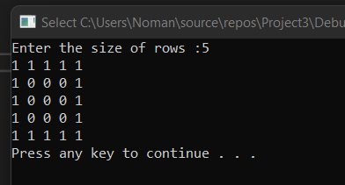

Question #7

Code:

#include<iostream>

using namespace std;

int main()

{

int helper = 1, helper2 = 1; /*Here we are intializing */

for (int i = 1; i <= 5; i++)

{

helper2 = 1;

for (int space = 5; space >= i; space--) /*This nested for Loop will print the spaces*/

{

cout << " ";

}

for (int j = 1; j <= helper; j++) /*This for Loop will display the Numbers that are required */

{

if (j >= (helper / 2) + 1)

{

cout << helper2;

helper2--;

}

else

{

cout << helper2;

helper2++;

}

}

helper += 2;

cout << endl;

}

system("pause");

return 0;

}

Output

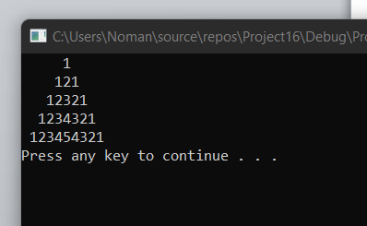

Question #8

#include<iostream>

using namespace std;

int main()

{

int rows, helper = 1, helper2 = 9;

for (int i = 1; i <= 5; i++) /*This for Loop will display the Lines */

{

cout << "|";

for (int space = 1; space <= i; space++) /*This Nested for loop will display Spaces*/

{

cout << " ";

}

for (int j = 1; j <= helper2; j++) /*This nested For Loop will print stars*/

{

cout << "*";

}

helper2 -= 2;

for (int space = 1; space <= i; space++) /*This for loop will also print spaces*/

{

cout << " ";

}

cout << "|";

cout << endl;

}

for (int i = 1; i <= 5; i++)

{

cout << "|";

for (int space = 5; space >= i; space--) /*This for loop will also print spaces*/

{

cout << " ";

}

for (int j = 1; j <= helper; j++) /*This nested For Loop will print stars*/

{

cout << "*";

}

helper += 2;

for (int space = 5; space >= i; space--)/*This for loop will also print spaces*/

{

cout << " ";

}

cout << "|";

cout << endl;

}

system("pause");

return 0;

}

Output

